**Add a condition to a flow**

Specify that a flow performs one or more tasks only if a condition is true. For example, specify that you'll get an email only if a tweet that contains a keyword is retweeted at least 10 times.

## **Add a condition**

1. In [Power Automate](https://flow.microsoft.com/), select **My flows** in the top navigation bar.

You might need to sign in if you're not already signed in.

1. In the list of flows, select one of the flows that you've created.

This tutorial uses an example with a Twitter trigger and a SharePoint action.

1. Select **Edit flow**.
2. Under the last action, select **New step**.
3. Select **Add a condition**.

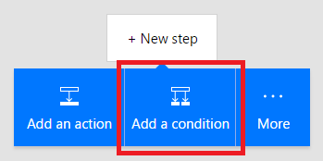

1. On the **Condition** card, select an empty area in box on the left.

The **Dynamic content** list opens.

1. Select the **Retweet count** parameter to add it to the box.
2. In the box in the middle of the **Condition** card, select **is greater than or equal to**.
3. In the box on the right, enter **10**.

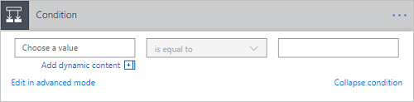

1. Select the header of the action you want to use inside the condition (such as **Create item**) and drag it underneath the text that reads **If yes**.

When you release the cursor, the action moves into that box.

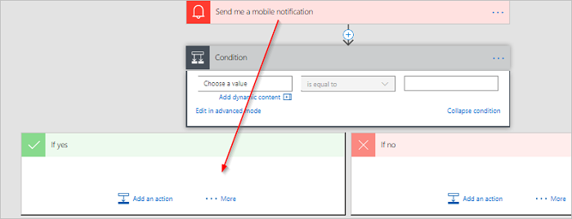

1. Configure the action as necessary.
2. Save the flow.